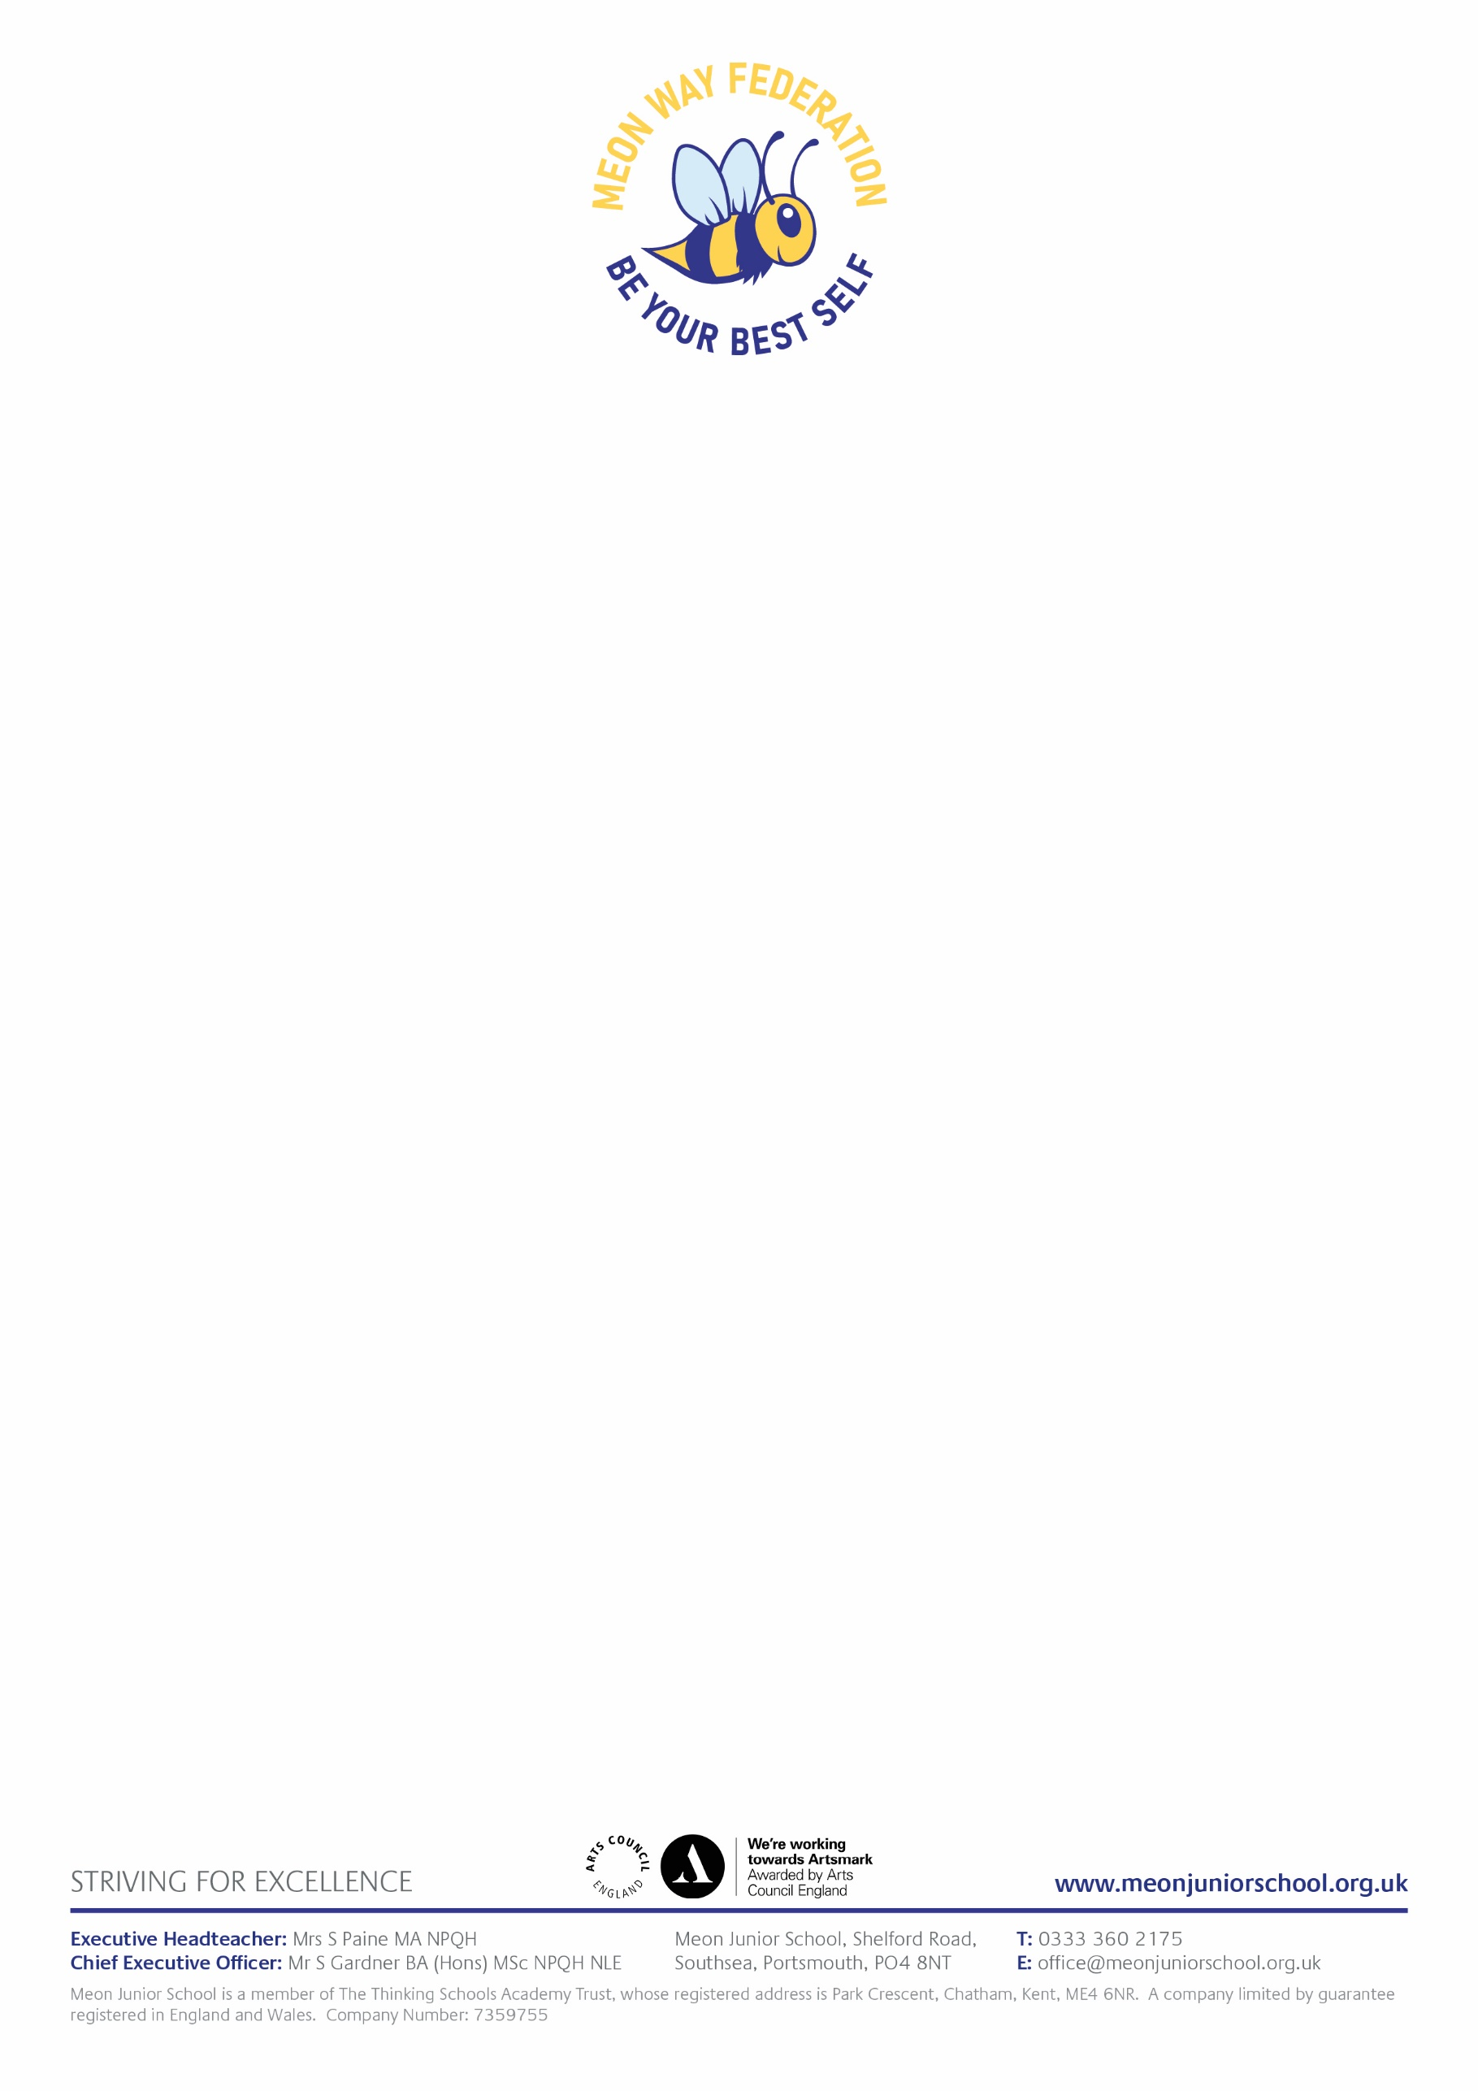Thursday 12th December 2024

Dear Parents & Carers,

On Thursday 19th December Years 4, 5 and 6 will be performing a Christmas carol concert at St James’ Church, Milton. Children will walk to and from the church.

Parents are invited to watch at the following times;

* **Year 4 & 5 1.30pm**
* **Year 6 9.30am**

The performance is expected to last around 45 minutes.

The children are required to be in uniform as normal and will be ­starting and finishing school at the usual time. If you are watcing the Year 4 and 5 performance which will finish around 2.15, you may take your children straight home from the Church.

Kind regards

Miss Turner

Head of Meon Junior School